44 Stats Video Lectures – Inference for comparing 2 paired means

1. Paired Means = Dependent Means
   1. when two sets of observations correspond with each other they are said to be paired. correspondence can be if both observations appear to be related mathematically in case by case observations.
   2. it’s useful to look at the difference of outcomes for each observation to see if the two outcomes have a relationship
2. Example of paired means: High school and beyond survey. Students take a reading a writing test. Reading and Writing are dependent on each other, so the means of the scores are considered dependent or paired means.
3. 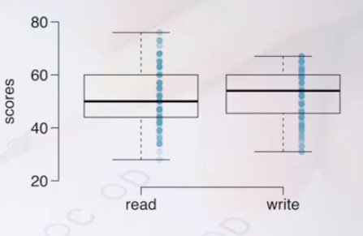
4. Reading scores are right skewed; as visible from the median being closer to the 25th percentile
5. Can we assume independence in reading and writing? No, an individual who scores high in Reading also tends to score high in writing
6. The parameter of interest in this example is the average difference between the Reading and Writing scores of all high school students
7. Our point estimate for the parameter of interest is the average difference between the Reading and Writing scores of the sampled students.
8. Running the numbers shows the examples all over the place, so let’s do a statistical inference
9. H0 – the difference between reading and writing skills is zero
10. HA – the difference between reading and writing skills is not zero
11. the example mean difference is xdiff = -0.544, the example standard dev is sdiff = 8.887 and the number of cases is n= 200
12. Find the T score: $\frac{observation-null}{\frac{s}{\sqrt{n}}}$ = $\frac{-0.545-0}{\frac{8.887}{\sqrt{200}}}$ = -0.867274
13. Now find the differences: df = 200 -1 = 199
14. Draw it out and find the distribution outside of the area, 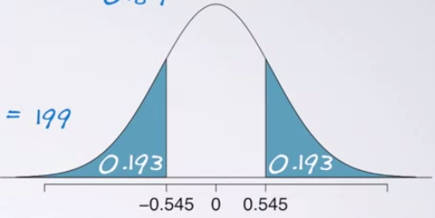t
    1. find the tail area using R



* 1. or using StatTrek.com/online-calculator/t-distribution.aspx and multiplying by 2

